Summary on London Plan 2011 – London’s Transport (Chapter 6)

Specific Vision:
To transform London into “a city where it is easy, safe and convenient for everyone to access jobs, opportunities and facilities with an efficient and effective transport system which actively encourages more walking and cycling, makes better use of the Thames, and supports delivery of all the objectives of this Plan”.
- Main Source of Policy on transport is the Mayor’s Transport Strategy
Main Strategies:
- encourage patterns and nodes of sustainable development that reduce the need to travel, especially by car
- seek to improve the capacity and accessibility of public transport, walking and cycling, particularly in areas of greatest demand
- support transport oriented development that generates high levels of trips at locations with high public transport accessibility and/or capacity
- improve interchange between different forms of transport
- strive to increase the use of the Blue Ribbon Network, especially the Thames, for passenger and freight use
- ensure that all parts of the public transport network can be used safely, easily and with dignity by all Londoners, including by securing step free access where this is appropriate and practicable

Public Realm and New Development
- To improve movement between places in an integrated way, emphasising the quality of the public realm, and the safety and comfort of travellers. A similar approach should be taken when planning the location of businesses, taking account of the ways they receive the goods and services they need, and how conveniently they then serve their customers.
- Emphasize the close coordination between landuse and transport. Shaping the pattern of development and influencing the location, scale, density, design and mix of land uses, can help reduce the need to travel and the length of journeys, and make it safer and easier for people to access jobs, shopping, leisure facilities and services by public transport, walking, and cycling.
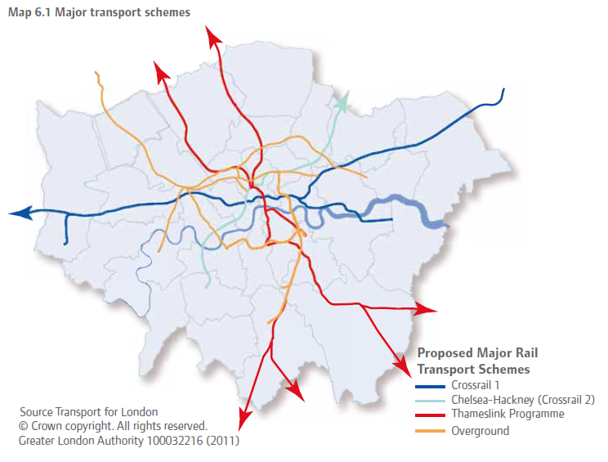
Cross Rail
- Crossrail is essential to delivery of the strategic objectives of this Plan. Demand for public transport into and within central London is nearing capacity, with crowding on Network Rail services and on London Underground routes towards the West End the City and Isle of Dogs.
Public Transport
- To maintain London’s world city status by improving its links with the rest of the world, including through taking a balanced and sustainable approach to additional airport capacity in south-east England
- Oppose the expansion of Heathrow Airport, but supports improvements of the facilities for passengers at Heathrow and other London airports in ways other than increasing the number of aircraft movements, particularly to optimise efficiency and sustainability, enhance the user experience, and to ensure the availability of viable and attractive public transport options to access them
- Work with TfL and boroughs to implement Londonwide improvements to the quality of bus, bus transit and tram services.
Coaches
- Investigate the feasibility of developing a series of coach hubs or the potential for alternative locations for coach station facilities to provide easier access to the coach network, while retaining good access to central London for coach operators.
Cycling
- New developments should provide cycle parking and changing facilities to encourage more cycling. To provide safer and more extensive cycling network
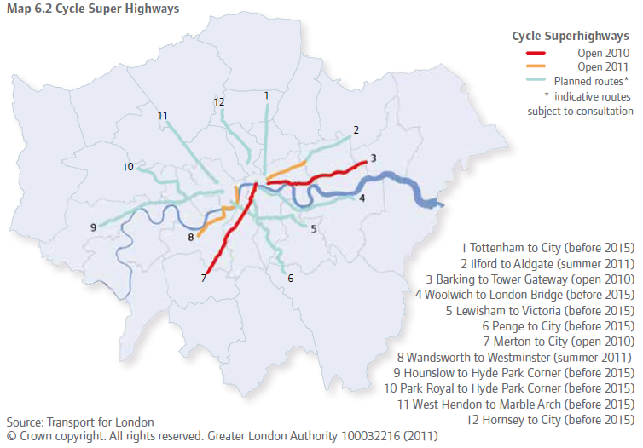
Walking
- To enhance walkability and legibility of London to encourage walking
- To achieve appropriate balance being struck between promoting new development and preventing excessive car parking provision that can undermine cycling, walking and public transport use.
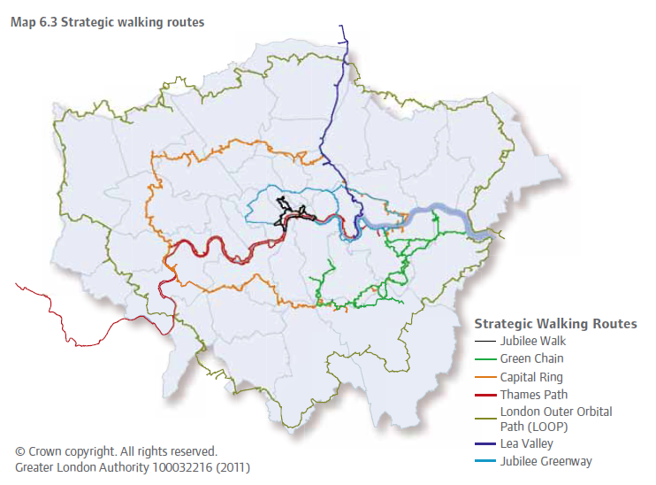
Freight
- Promote movement of freight by rail and waterway instead of by road. The Mayor supports the development of corridors to bypass London, especially for rail freight, to relieve congestion within London. To promote better and smoother strategic rail freight interchange

