Putting low-income households at the heart of the London Plan

The New Policy Institute
- This response to the draft London Plan has been written by the New Policy Institute (NPI). As authors of the London Poverty Profile (LPP), we believe that the interests of low-income households should be a priority for the London Plan and given explicit consideration as it is put into practice.
- The response has three parts:
- Introduction: why low-income households should be a priority for the Plan.
- Overview of the proposed amendments to the Plan.
- Detailed amendments and the arguments for them.

Introduction: why low-income households should be at the heart of the Plan
- According to the latest LPP, 27 per cent of Londoners (2¼ million people) were in a low-income household in 2015/16 (the latest year for which data has been published). We are measuring low income in the same way as it is measured in official poverty statistics. We prefer the term “low income” to “poverty” here for two reasons. The first is that is a precise description of what is being measured. The second is to undercut the sense that these households are different from the rest not just in degree but somehow in kind too. We cannot emphasise enough “the poor” are not a tribe apart.
- In which case, why focus on them? Because if their circumstances are similar to those of many other Londoners, the challenge they face is necessarily more acute because of their reduced resources. Put the other way, if London is well-planned for those in low-income households, it is going to be well-planned for many others too.

Key characteristics of low-income London households
- By definition, low-income households are short of money. But – and this is a key insight from our studies of poverty in London and across the UK – they short of money, they are also typically short of time too. This is particularly true of that majority of low-income Londoners who are in households where one or more members are doing paid work (aka “in-work poverty”).
- Figure 1 represents the 2¼ million Londoners living in low-income households according to their family work status. It shows that:
- 59 per cent (split 37:21 between adults and children) are in families where at least one adult is doing paid work.
- 31 per cent are children (split 21:10 between working and non-working families).
- Eight per cent are pensioners in non-working families (with a further 0.6 per cent in working families).

Figure 1. People in low-income London households by family work status and age group
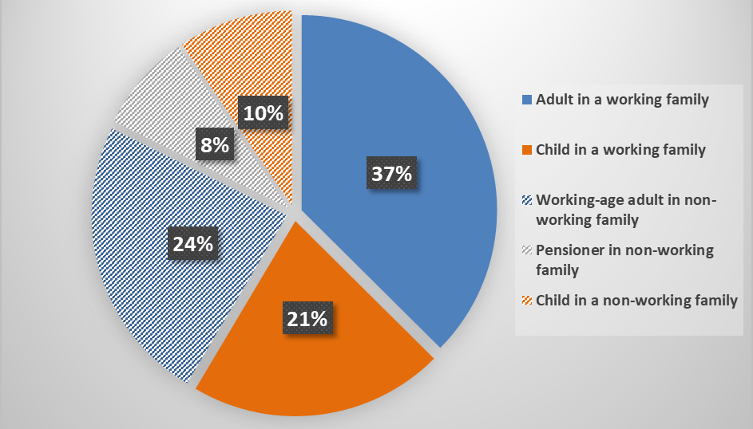
Source: HBAI, DWP. The data is for London and is a three-year average to 2015/16.
- Figure 2 shows the 37 per cent of people in low income who are adults in working families (as per Figure 1) according to their individual work status:
- 53 per cent are women and 47 per cent are men.
- 35 per cent are employed full-time, 20 per cent part-time and 23 per cent are self-employed.
- 21 per cent are neither employed nor self-employed.
- Further analysis of this data shows that 78 per cent of the people in low-income, working families are in households containing either a child, a disabled adult or a pensioner. The high care and support commitment that this implies, combined with the 79 per cent employment rate for the adults in these families, points to the time pressures these families are likely to be under – without any financial cushion to fall back on.

Figure 2. Adults in low-income, London working households by gender and employment

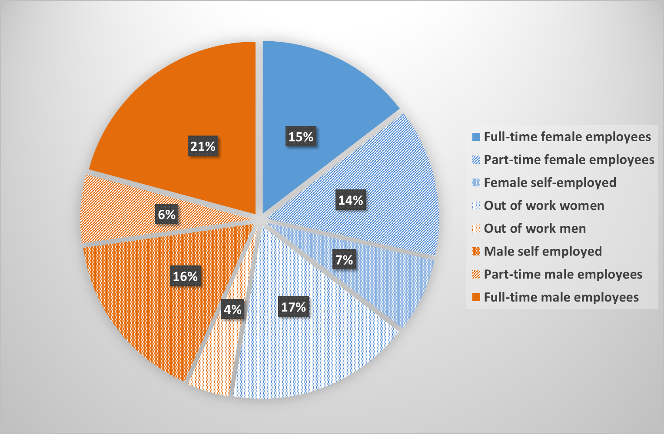
Source: HBAI, DWP. The data is for London and is a three-year average to 2014/15.

Implications for the London Plan
- On the basis of this straightforward analysis, we draw two conclusions about this population of low-income Londoners which makes them a suitable focus for the Plan.
- Short of money by definition, low-income households are also pressed for time, with significant caring responsibilities and elevated levels of part-time jobs. This is what unites them.
- At the same time, they are diverse, with the four equalities groups – age, sex, disability and race – well represented. Far from conforming to a simple stereotype, they nevertheless have fundamental interests in common.
- What might the impact of the matters dealt with in the Plan be on low-income households? At this stage, we see three groups of connections, all of which have a spatial dimension to them:
- Low-income adults will be especially cost sensitive, especially for housing but also travel; with less resources to spare, they may also be more risk-averse.
- With higher numbers of dependents, they will make greater use of local public services (schools, health, care, parks, leisure services, etc).
- Their journey patterns will be more local (on average, people doing low paid jobs travel less far to work) and/or orbital (a majority of London’s low-income households live in outer London), complex (making trips with multiple purposes) and varied (things crop up, whether at school, with an elderly relative, etc) than those who commute daily to a full-time job. Rail is less important, bus more so. A series of reports by Transport for London (for example, this one on gender) would seem to be in accord with this view, although a deeper examination is required to establish that properly.
- A focus on low-income households fits with the importance that the Plan attaches to housing. As the LPP shows, the high cost of housing is the main cause of London’s elevated poverty rate compared with the rest of the country. Rents are high and have risen in recent years, while provision of affordable housing in London continues to fall short of targets.
- The LPP also highlights the acute consequences of the housing problem. The most recent year of data (2015/16) saw no increase in rough sleeping while homelessness acceptances began to decline after consistent increases since 2009/10. Even so, both are still significantly up on a few years ago, despite record employment levels.
- Yet while the affordability of housing is at the centre of the challenge facing London’s low-income households, suitable jobs and suitable social infrastructure, including schools, health services and child care, are no less essential. To meet the needs of low-income households with their stronger local focus, these need to be both accessible (in multiple ways) and of good quality (in multiple ways too)
- A focus on low-income households can also serve as a counterweight to undue attention to the “commuter”, who makes a daily, radial journey, usually by train, from outer London or beyond, towards or into the centre. It is not that low-income households don’t use rail or don’t commute to the centre (there is evidence that a small number of low paid people spend as long as anyone travelling to work in London). But close attention to low-income Londoners pushes in the direction of ensuring that the complexity of how London is used by those who live here is given proper attention in the Plan itself and as it unfolds over the coming years.

Overview of proposed amendments
- Our 17 proposed amendments to the Plan serve 11 objectives spread across nine chapters. To provide an overview, the following is a list of the objectives which each group of amendments is aimed at achieving (chapters in brackets):
- make improvements for low-income Londoners an explicit goal of the Plan (chapter 1)
- ensure that low-income Londoners’ interests and needs are protected in Opportunity Areas (chapter 2)
- ensure that opportunities for low-paid workers to live in or near the CAZ are increased (chapter 2)
- ensure housing and public space design is accessible for all Londoners (chapter 3)
- make housing affordable for low-income Londoners (Chapter 4)
- ensure that low-income Londoners have the right social infrastructure for their needs (Chapter 5)
- require boroughs to give proper consideration to communities living close to SILs (chapter 6)
- include low-income residents in plans for Creative Enterprise Zones (chapter 7)
- ensure that decisions about transport schemes are clear, consistent and contestable (chapter 10)
- ensure that low-income households’ travel behaviours are reflected in planning decisions (chapter 10)
- ensure that outcomes for low-income households are monitored as the Plan is implemented (chapter 12)
- In summary, what the amendments are trying to do is this. The first of them – to make the needs and interest of low-income Londoners a priority within the Plan – is fundamental. This objective then takes specific form in proposals around Opportunity Areas, Strategic Industrial Areas, and the Central Activity Zone. Leaning on the Strategic Housing Market Assessment, it urges a strengthening of the Plan’s commitments on affordable housing. It underlines the importance of social infrastructure understood broadly. And it urges a more balanced view of public transport with current, local travel needs given due attention.
- While we are confident that the basic argument for giving priority to low-income Londoners is well-founded, the practical expression of that viewpoint still requires careful elaboration. In order to achieve this, we propose that Supplementary Planning Guidance should be drawn up to explain how it can be done. The discussion and consultation required to do that is therefore pivotal. Finally, to underpin the whole exercise, we propose that the Key Performance Indicators be supplemented with a matching set of measures to monitor the impacts on low-income households.

Proposed amendments to the Draft London Plan
No. | Reference | Purpose | Proposed amendment | Explanation

Objective: to make improvements for Low Income Londoners an explicit goal of the Plan (chapter 1)
1a. | Policy GG1 | To identify low-income households as a priority within the Plan and ensure their interests are given explicit consideration. | Add new bullet between “A” and B”:  - Give explicit attention to the situation and needs of low-income households in their areas. | Low-income, working households are both short of money and pressed for time, due to caring responsibilities and part-time jobs. As a result, they: are cost sensitive; have higher dependence on and more interaction with local public services; have more local and varied and travel patterns; have a larger stake in the local area. Explicit attention to their needs will provide evidence that policies and decisions are making London fairer and more equal.
1b. | Chapter paragraphs | To create a commitment to publish Supplementary Planning Guidance re low-income London households | Insert new paragraph (1.1.6) after 1.1.5:  The Mayor will prepare Supplementary Planning Guidance to help boroughs, TFL and others implement the policy of giving explicit consideration to the interests of low-income households and to reduce inequalities more generally. | The practical implications of giving explicit consideration to the interests of low-income households depends on both the boroughs and the London-wide authorities. TFL in particular faces the perennial challenge of resource allocation across the capital and between different modes of transport. TFL’s projected operating deficit in 2018/19 of close to £1bn gives this matter a new and heightened urgency.

Objective: to ensure that low-income Londoners’ interests and needs are protected in Opportunity Areas (chapter 2)
2. | Policy SD1 | To require the boroughs explicitly to address and help reduce inequalities and give due attention to low-income Londoners. | Insert new point after (1) in B:  - In consultation with local communities, define and measure spatial inequalities and environmental, economic and social barriers affecting the lives of people in the area – and publish evidence that shows how a development in the Opportunity Area will reduce them.  Add to existing point (9) in B  and contain evidence showing how a development in the Opportunity Area will reduce spatial inequalities and lower environmental, economic and social barriers – and how that will be monitored. | The Draft gives Mayor a responsibility for reducing inequalities (1A6). This additional paragraph strengthens that by setting the policy context of the Boroughs’ Sustainable Community Strategies, supported by the proposed SPG. Low-income Londoners are at the heart of this.  Proposed amendments to chapter 12, on monitoring, serve the purpose of capturing evidence to ascertain how far low-income benefits are indeed benefitting from the changes taking place.
3a. | Policy SD1 | To require TFL to work with boroughs to support the interests of low-income Londoners now and in the immediate future. | Add new point C:  TFL, in consultation with boroughs and local communities, should take account of spatial inequalities and environmental, economic and social barriers affecting the people in the more disadvantaged localities and bring forward changes to public transport provision to reduce them. | Since TFL is central to addressing these inequalities, it must work with boroughs to support the interests of low-income Londoners now and in the immediate future. Identifying schemes that can potentially do this, and then working them up into viable projects, is crucial here. It should be an enduring priority for TFL.
3b. | Chapter paragraphs | To clarify that people who live and/or work in Opportunity Areas today – and their interests – are an ongoing priority and must be attended to throughout. | 2.1.1: add at end:  At the same time, Opportunity Areas are where hundreds of thousands of people live and work today. The Mayor will ensure that the balance between current and future interests and needs is kept under review at all times.  2.1.5: replace:  The major transport infrastructure that facilitates this acts as a vital catalyst  with:  Major transport infrastructure is one part of this  2.1.5: add at end:  At the same time, improving access within the capital, especially for journeys to, from and between local destinations, is an ongoing requirement and can neither be deferred until, nor sacrificed to, future major transport infrastructure.  2.1.11: add at end:  Giving explicit attention to meeting current needs and overcoming current inequalities and barriers will reinforce this requirement | These changes to the supporting/explanatory text are intended to reinforce the proposed amendments to the policy SD1. The explanations for those amendments also provides the underlying justification here.

Objective: to ensure that opportunities for low-paid workers to live in or near the CAZ are increased (chapter 2)
4. | Policy SD5 | To amend the Plan to allow a more balanced approach to housing in or near the CAZ, to allow more of those with low paid jobs in the CAZ to live nearby | Add to A:  But neither should pursuit of those strategic functions [of the CAZ] be at the expense of the low paid workforce on which it depends nor the Mayor’s goal of promoting walking and cycling.  Delete C(4), D(1) and D(2) | About 1 in 6 low paid jobs in London are in the central area, at a job density four times that of the all-London average. Just under half of all low paid jobs in London are in Inner London. The higher cost of commuting (relative to earnings) for those doing low-paid work means that is in their interests to live as close to work as possible. Given the higher job densities in central and inner areas, maximising the number of low-cost rented homes (social rent/London Affordable rent) within or close to the CAZ is also an effective way of supporting the Mayor’s goal for 80 per cent of trips to be walk, cycle, or public transport by 2041. While a balance must be struck between competing uses, policy SD5 as drafted adopts an extreme position.

Objective: to ensure housing and public space design is accessible for all Londoners (chapter 3)
5. | Policy D5 | To provide adequate affordable housing for London’s diverse population, including those requiring accessible housing | To add new point:  - half of the 10 per cent required accessible housing (in 1) to be affordable to Londoners on a low income. | With disabled people in London more likely to be low paid (37 per cent of disabled workers are low paid compared with 27 per cent of non-disabled workers), and people with a disabled adult in the family more likely to be in poverty than those without (35 per cent compared with 25 per cent it is necessary for housing to be provided to meet a range of income brackets including those suitable for people on a low income.

Objective: to make housing affordable for low-income Londoners (Chapter 4)
6. | Policy H3 Monitoring housing targets | To monitor the number of affordable homes built | Add new paragraphs (E and F)  The number and proportion of homes that are Social Rent or London Affordable Rent as well as the proportion of market rent at which these are set should be monitored and published by borough and by development.  The number and proportion of homes that are London Living Rent and London Shared ownership should be monitored and published by borough and also by development. | The Plan identifies delivering more affordable housing as a strategic objective. The number and proportion of affordable homes delivered should therefore be monitored to make sure that the proportions set out in Policy H5 and H6 are being met. As there are now a number of ‘affordable’ housing products available the number and proportion of each type delivered should be made clear.
7. | Policy H6 Threshold approach to applications | To increase the proportion of affordable homes provided to Londoners | Delete B1, B2 and B3 and replace with:  B1) a minimum of 40 per cent affordable housing OR 30 per cent low-cost rent (social rent or London affordable rent)  B2) 47 per cent low cost rent (social rent or London Affordable rent) and 18 per cent intermediate for: public land; Strategic Industrial Locations; Locally Significant Industrial Sites; other industrial sites deemed appropriate to release for other uses. | The 2017 Strategic Housing Market Assessment (SHMA) has identified that 65 per cent of housing in London needs to be affordable with 18 per cent of these intermediate housing products and 47 per cent low-cost rent. The threshold level of affordable housing set at 35 per cent is therefore barely half what is required.  To give the SHMA real force, some developments must adhere to the letter of its recommendations. This amendment identifies which those should be. It also raises the general threshold and prioritises low-cost rent housing (social rent or London Affordable rent)
8. | Policy H6 Threshold approach to applications | To make viability assessments more transparent. | Add to F:  Viability assessments should be made publicly available. | Where viability assessments are required these should be open to public scrutiny. This is intended to ensure a focus on the maximum delivery of affordable homes

Objective: to ensure that low-income Londoners have the right social infrastructure for their needs (Chapter 5)
9a. | Policy S1 Developing London’s social infrastructure | To ensure that all Londoners have access to the right social infrastructure for their needs. | Add to A:  following the guidance provided by the Mayor in his Supplementary Planning Guidance on social infrastructure | It is noted in 5.1.1. that ‘social infrastructure ‘can contribute towards a good quality of life’ and ‘play and important role in developing strong and inclusive communities’. Although boroughs are required in Policy S1 Developing London’s social infrastructure to undertake a needs assessment there are no guidelines which they should follow. This gap should be remedied.
9b. | Paras in chapter | To create a commitment to publish Supplementary Planning Guidance re low income London households | Add to para 5.1.2:  The Mayor will research and publish Supplementary Planning Guidance to help boroughs and others that sets out minimum criteria for social infrastructure to meet the needs of London’s diverse communities. | To action the above.
10. | Policy S2 Health and social care facilities | To ensure Londoners have appropriate and equal access to health and social care facilities | Add at end of A3  and prioritise the reduction of inequalities in access to provision faced by low-income Londoners  Amend C to read:  New and existing facilities should be easily accessible by public transport, cycling and walking. Londoners should be able to access a GP within 15 minutes of travel. | Research into Acceptable Place Standards found strong agreement amongst participants that access to GPs within walking distance of homes was important. 15 minutes was favoured by many. The Plan notes that the NHS General Practice forward view supports the provision of primary care at greater scale. Whilst this may be the best model for patient care, it will mean that accessibility via public transport will need to be carefully considered.  Cycling may not be the best mode of transport for the groups of people who access the GP most frequently and have disability and health issues.
11. | Policy S3 Education and childcare facilities | To ensure Londoners have appropriate access to education and childcare facilities. | Add new paragraph to A:  - Where possible good quality primary schools and affordable child care should be within walking distance of people’s homes. Air quality is a crucial aspect of “quality” in both these cases. | Research into Acceptable Place Standards found strong agreement amongst participants that access to primary education should be within walking distance of homes.

Objective: to require boroughs to give proper consideration to communities living close to SILs (chapter 6)
12. | Policy E5 | To give low-income Londoners who live near and/or work in SILs proper attention in the development of the SIL. | Add to end of A.  Most SILs are likely to continue to have a high proportion of low-income Londoners living nearby. In managing SILs to meet the goal set for them, the interests of nearby low-income areas should be fully taken into account.  Add new paragraph after B(1):  Also define a boundary for the wider “SIL and its immediate vicinity”, taking guidance from the Mayor and relevant Supplementary Planning Guidance as an area where priority will be given to improving social and environmental facilities for existing residents who are impacted by the SIL.  Add new paragraph B(4):  - ensure that the SIL and its immediate vicinity has sufficient provision of public services, green and social infrastructure and affordable housing, using the current facilities and uses made of the area as a minimum standard against which future plans are measured.  In C(6) replace  such as  with  including, but not limited to | There is an affinity between SILs (figure 6.2) and local areas with high concentration of low-income households (LPP figure 3.11). For a variety of reasons (where the jobs are located; the relative unattractiveness of living in or near a SIL) this will remain so. SIL development should pay explicit attention to the needs and choices of current residents (in/near SIL).
13a. | Policy E11 | To ensure that the various forms of education and training offered, including apprenticeships, are capable of achieving at least a minimum standard of attainment | In B insert after “(a) enable trainees to complete their training and apprenticeships”  To a minimum recognised level of attainment  Add new paragraph C:  In consultation with employers and education and training specialists, the Mayor will publish minimum levels of attainment. Development proposals should be such that that those levels can feasibly be realised. Boroughs, singly or together, will work with developers and others to make this possible. | The skills development, apprenticeship and other education and training opportunities made possible by development proposals are only worthwhile if they allow those taking advantage of them to reach at least minimum acceptable standard. Para 6.11.3 notes that it is often not possible under current arrangements to acquire qualifications. With 35 per cent of 19-year-olds across inner and outer London lacking qualifications at level 3 (LPP, fig 10.4), the challenge is considerable.  With the Mayor setting the standard, boroughs will need to work with developers and others to find ways to ensure that these standards can be achieved. As the LPP (fig 10.6) also shows, there is a lot of variation between boroughs in the proportion of young adults lacking adequate qualifications.
13b | Chapter paragraphs | As above | Add to 6.11.3 after “unable to complete their training”  In order to overcome this, the Mayor will, after consultation, set minimum standards so as to ensure that agreements do provide for meaningful completion, rather than mere starts. | As above

Objective: to include low income residents in plans for Creative Enterprise Zones (chapter 7)
14. | Policy HC5 | Proposals for Creative Enterprise Zones must provide economic and cultural opportunities for resident, low-income Londoners. | To add new point in C after 1  - provide a range of work spaces, especially those required by low income, self-employed Londoners, to create opportunities for economic activity by people living locally. | Good growth must provide for the needs and ambitions of current low-income residents as part of creating sustainable growth of a local economy. Just as a proposed national industrial strategy contains the “ambition to achieve positive outcomes and make material differences to people’s everyday lives, and not confine itself to a few ‘sector deals’”, so support in the Plan for local economic growth should not restrict its scope to high-tech or other leading-edge sectors alone.

Objective: to ensure that decisions about transport schemes are clear, consistent and contestable (chapter 10)
15. | Policy T1 | To ensure that the basis on which major decisions as to which transport schemes are accorded priority is clear and contestable | Add new paragraph C:  The basis on which decisions are made between the proposed transport schemes in Table 10.1 will be open, clear and consistent over time. The schemes will continue to be viewed as a whole, with a decision to proceed with any one of them taking account of the consequences for others. Due attention will be paid throughout to the transport and travel needs of low-income Londoners | Transparency is necessary to reinforce SD1 as outlined in poin 3a above.  “Adverse consequences” include delay, downsizing or cancellation

Objective: to ensure that low-income households’ travel behaviours are reflected in planning decisions (chapter 10)
16a. | Policy T6 | To avoid over-dependence on PTALs as the measure of public transport accessibility | Insert new paragraph after A:  PTALs are the starting point for measuring public transport accessibility but they are imperfect. In particular future transport accessibility which depends heavily on a mode of travel that current residents make little use of should not automatically be preferred to the measure of existing accessibility | As the glossary to the Plan notes, (pp521-2), PTALs are limited in “that they only reflect access to the public transport network, but not the opportunities and services reachable through the network”. Put another way, PTALs are a useful guide but it should not be policy to use them mechanically.
16b | Chapter paragraphs | To ensure that the limitations in the way in which public transport accessibility is measured are acknowledged and suitable adjustments allowed | 10.6.2: insert after “difficult”  and radial rail services irrelevant  10.6.4: insert before “future”  existing and  Add new para after 10.6.4:  Particular care should be taken in SILs and their immediate vicinity (see policy E5 as per 12 above) that show evidence of high car dependency. A much-improved PTAL which does not deliver big improvements for current residents and employees may not serve the Mayor’s 2041 target of 80 per cent. | The introduction of a new transport mode – or a major service enhancement to an existing mode – can greatly improve access to the network without necessarily improving travel for most existing users in the local area.  TFL makes its rich data on travel time publicly available via WebCAT. Used in conjunction with information on actual journey patterns, access measures which reflect local usage can be constructed and set alongside PTALs

Objective: to ensure that outcomes for low-income households are monitored as the Plan is implemented (chapter 12)
17a | Policy M1 | To underpin the priority of low-income households in the Plan by creating a commitment to measure outcomes for them. | Policy M1. Add new point B:  In monitoring the implementation of the London Plan, explicit attention will be paid to how far the benefits are being felt by all groups of Londoners. Within this, monitoring the impacts of the Plan’s implementation on low-income Londoners will be a priority. | Most key performance indicators are output measures. Supplementing them with a selection of outcome measures can focus attention on who is enjoying the benefits and how far needs remain unmet. A commitment to measure outcomes for low-income households is an essential unpinning to the principal that the interests and needs of such households should be a priority for the Plan.
17b | Chapter paragraphs | As above | Add new para after 12.1.1  To supplement the measures shown in table 12.1, a review will be conducted to identify an additional measure for each KPI to capture the impact on low-income households. A further measure, to capture impacts on equalities groups, will also be considered.  Add at end of first para. in 12.1.3:  but are not restricted to | As above.  The question of how to monitor outcome for low-income households is directly related to question of how the Plan can give explicit consideration to their interests. In practice, therefore, this review is closely aligned to the work that goes into preparing the Supplementary Planning Guidance proposed above in 1b.

