Towards a new London Plan - Update from Deputy Mayor, Jules Pipe 18th June 2025

Transcript of video (https://consult.london.gov.uk/towards-a-new-london-plan-consultation/videos/5607 or now https://www.youtube.com/watch?v=SXjuCeu4Ths&t=24s )
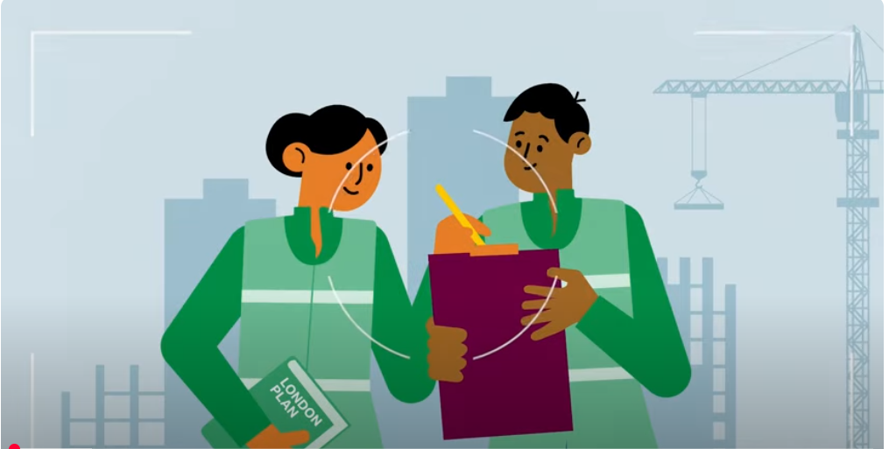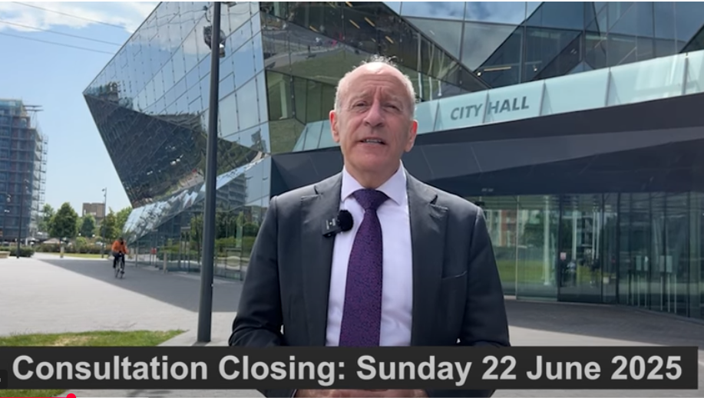

Good morning from the Royal Docks.
Since the mayor launched the Towards a New London plan document, it's been a really hectic and busy few weeks with nearly 40 events under our belt and we're now in the final stretch of our public engagement. And I'd like to thank everyone who has taken part so far.
With the consultation period coming to a close soon, I thought it would be a really good point to share with you some of the priorities and comments that I've been hearing and I've been feeding- back to the mayor alongside colleagues from the mayor's planning team. and I've met with industry, borrowers, community groups, interest groups, and Londoners themselves, and thousands of comments have been made across our engagement platforms.
Overall, it's clear Londoners really care about where growth in our city should go, and they want to be involved in shaping that process. They’ve welcomed the opportunity to have an open and frank conversation on issues that our city faces. From the comments received, there's an understanding of the strategic nature of this document and what it can do and what it can't do.
On housing, we're hearing that Londoners want their needs put first. There are concerns about the quality of existing homes, too. And as you'd expect, high rents, service charges, and the affordability of mortgages are a huge worry. Understandably, while there is a concern around the increase in London’s housing need to 880,000 homes or 10 years supply, the approach set out in the consultation document has generally been considered pragmatic, including the approach to the green belt.
However, retaining open space is another priority. The need for open space that is improved and more accessible to Londoners and usable has been made loud and clear. Londoners want well-being to be prioritized in a city with healthier and happier people to be one of the things the next London plan enables. Londoners also want the efficient re-use of existing empty buildings and land, a focus on regeneration and improved transport links.
On the economy, like all economies across the globe, London’s was impacted by the pandemic, but it recovered strongly, returning to pre-pandemic annual output levels by 2024. There have been shifts in working practices and shopping patterns as well and we need to look at the implications of these changes in different parts of London. The link between the provision of suitable housing and growing the economy is really understood and appreciated. We know that good quality housing is not only essential for Londoners but for attracting and retaining a skilled workforce and revitalizing neighbourhoods. Londoners also care about the health of their local high streets. Affordable workspaces to encourage innovation, and they want to see more independent businesses. Safety for night-time workers has been raised as a transport network that works and connects every part of the city.
We're at a key crossroads to plan for London's future, and Londoners have an opportunity to shape how their city grows and get this once-in-a-generation opportunity right. I can't stress enough how important it is to take part. Nobody sees London like you do, which is why we would love to hear from you.
[Click the link and have your say.]

